PANDAS PROGRAMS

1. Create a Pandas Series from a list of student marks and display the Series

Aim: To write a Python program to create a Pandas Series from a list of student marks and display the Series.

Algorithm:
- Start.
- Import the Pandas library.
- Create a list containing student marks.
- Convert the list into a Pandas Series using Series().
- Display the Series.
- Stop.

CODE AND OUTPUT:

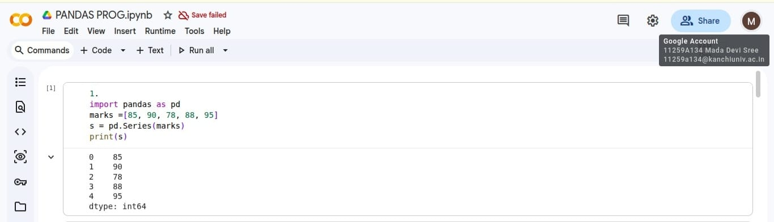

Result:
Thus, the Pandas Series was created and displayed successfully.

2. Create a DataFrame containing student details

Aim: To write a Python program to create a DataFrame containing student details such as Roll No, Name, Department, and Marks.

Algorithm:
- Start.
- Import the Pandas library.
- Create a dictionary containing Roll No, Name, Department, and Marks.
- Convert the dictionary into a DataFrame using DataFrame().
- Display the DataFrame.
- Stop.

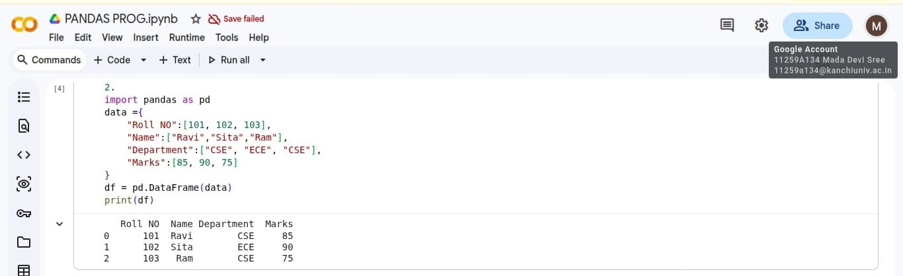
CODE AND OUTPUT:

Result:
Thus, the Python program to create and display a student DataFrame was executed successfully.

3. Read a CSV file and display the first and last five records

Aim: To write a Python program to read a CSV file using Pandas and display the first and last five records.

Algorithm:
- Start.
- Import the Pandas library.
- Read the CSV file using read_csv().
- Display the first five records using head().
- Display the last five records using tail().
- Stop.
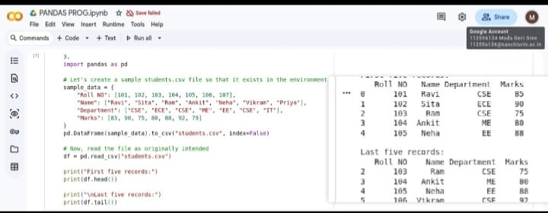
CODE AND OUTPUT:

Result:
Thus, the Python program to read a CSV file and display the first and last five records was executed successfully.

4. Find summary statistics of a DataFrame

Aim: To write a Python program to find the mean, median, minimum, maximum, and standard deviation of a DataFrame.
Algorithm:
- Start.
- Import the Pandas library.
- Create a DataFrame containing numerical data.
- Calculate the mean using mean().
- Calculate the median using median().
- Find the minimum using min().
- Find the maximum using max().
- Calculate the standard deviation using std().
- Display all the calculated values.
- Stop.
CODE AND OUTPUT:
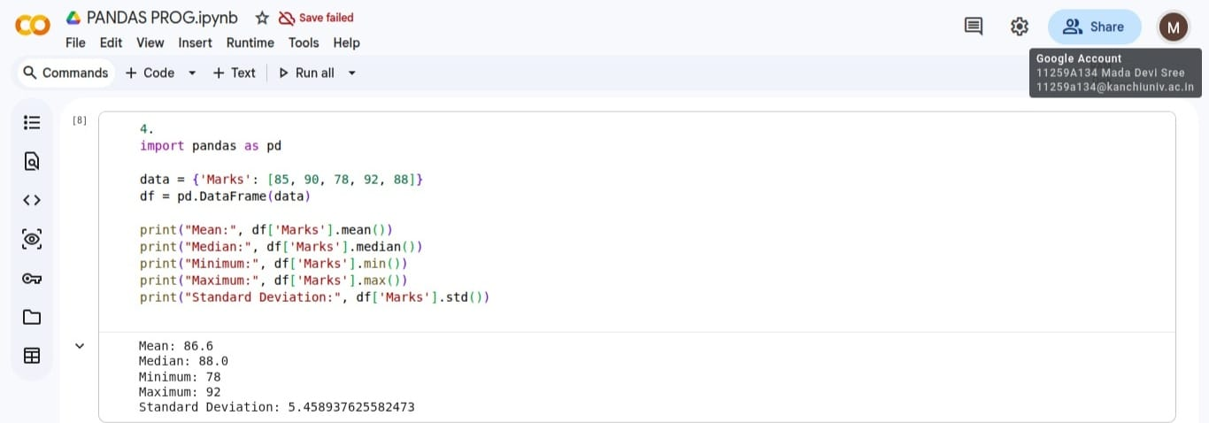

Result:
Thus, the Python program to calculate summary statistics of a DataFrame was executed successfully.

5. Select students who scored more than 75 marks

Aim: To write a Python program to select students who scored more than 75 marks from a DataFrame.

Algorithm:
- Start.
- Import the Pandas library.
- Create a student DataFrame containing student details and marks.
- Apply the condition Marks > 75.
- Store the students satisfying the condition.
- Display the selected student records.
- Stop.

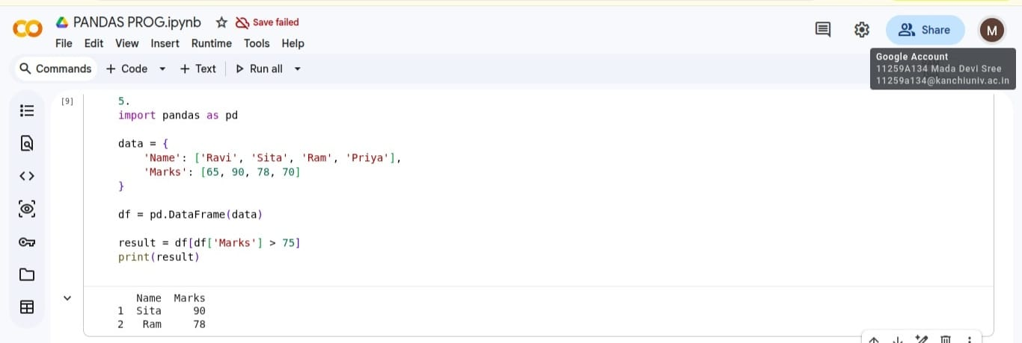
CODE AND OUTPUT:

Result:
Thus, the Python program to select students who scored more than 75 marks was executed successfully.

6. Add a Grade column to a student DataFrame

Aim: To write a Python program to add a new column called Grade to a student DataFrame based on their marks.

Algorithm:
- Start.
- Import the Pandas library.
- Create a student DataFrame containing student marks.
- Define grade conditions based on the marks.
- Create a new column named Grade using the grade conditions.
- Display the updated DataFrame.
- Stop.

CODE AND OUTPUT:
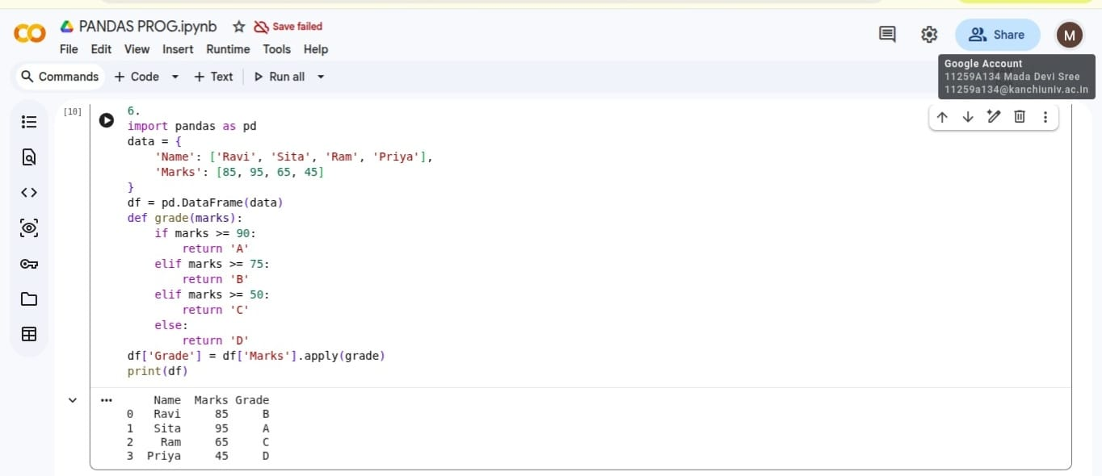
Result:
Thus, the Python program to add a Grade column based on student marks was executed successfully.

7. Identify and remove missing values from a DataFrame

Aim: To write a Python program to identify and remove missing values from a DataFrame.

Algorithm:
- Start.
- Import the Pandas library.
- Create or load a DataFrame containing some missing values.
- Identify missing values using isnull().
- Display the missing-value information.
- Remove rows containing missing values using dropna().
- Display the updated DataFrame.
- Stop.

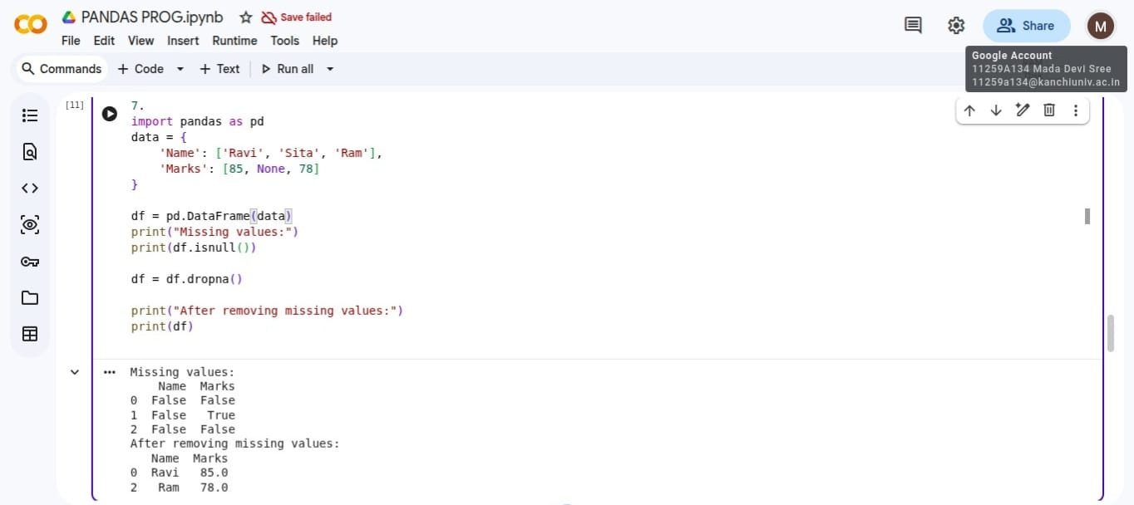
CODE AND OUTPUT:

Result:
Thus, the Python program to identify and remove missing values from a DataFrame was executed successfully.

8. Sort a DataFrame based on student marks in descending order

Aim: To write a Python program to sort a DataFrame based on student marks in descending order.

Algorithm:
- Start.
- Import the Pandas library.
- Create a student DataFrame containing marks.
- Sort the DataFrame using sort_values().
- Set ascending=False to arrange marks from highest to lowest.
- Display the sorted DataFrame.
- Stop.

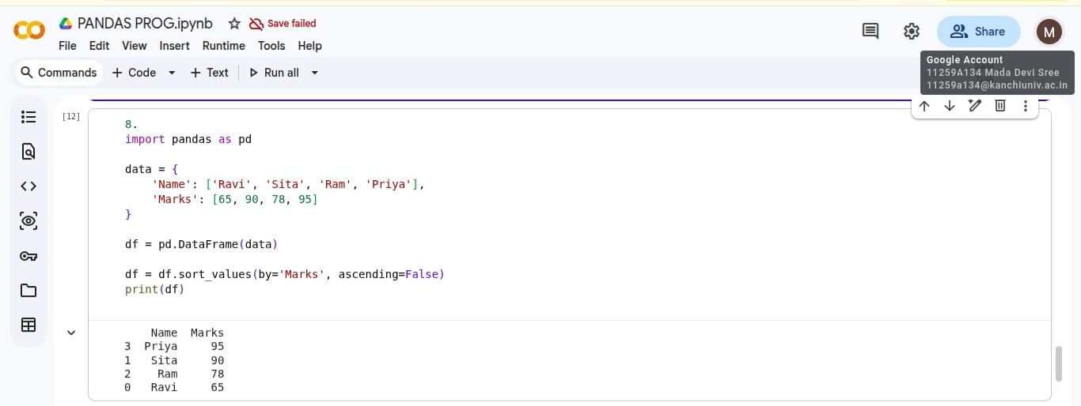
CODE AND OUTPUT:

Result:
Thus, the Python program to sort student marks in descending order was executed successfully.

9. Group students by department and calculate average marks

Aim: To write a Python program to group students by department and calculate the average marks for each department.

Algorithm:
- Start.
- Import the Pandas library.
- Create a DataFrame containing student names, departments, and marks.
- Group the students by department using groupby().
- Calculate the average marks using mean().
- Display the average marks for each department.
- Stop.

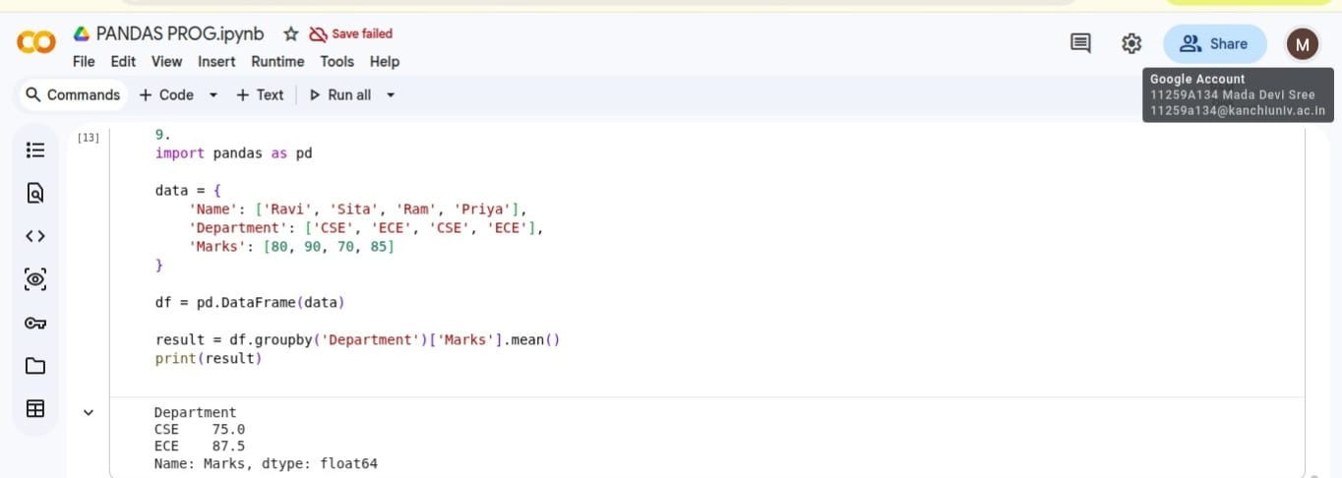
CODE AND OUTPUT:

Result:
Thus, the Python program to group students by department and calculate average marks was executed successfully.

10. Save a modified DataFrame to a new CSV file

Aim: To write a Python program to save a modified DataFrame to a new CSV file after updating student records.

Algorithm:
- Start.
- Import the Pandas library.
- Create or load a student DataFrame.
- Update the required student records.
- Save the modified DataFrame using to_csv().
- Set index=False to avoid saving the row index as an extra column.
- Display a message confirming that the file has been saved.
- Stop.

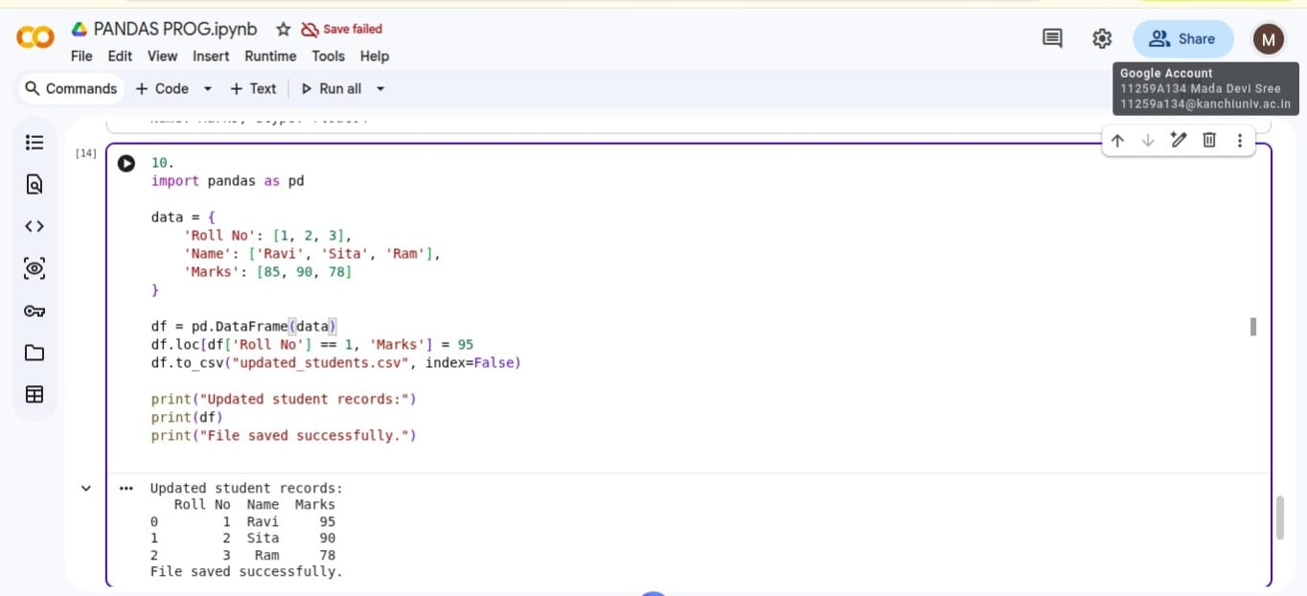
CODE AND OUTPUT:

Result:
Thus, the Python program to group students by department and calculate average marks was executed successfully.

